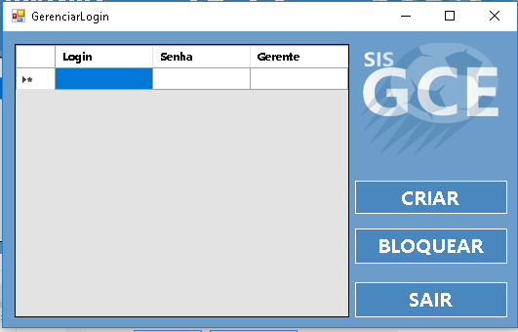

|  |  |  |  |  |
| --- | --- | --- | --- | --- |
| **CT NO.** | **PROPOSITO** | | | |
| **1** | **VERIFICAR SE CRIAR O LOGIN** | | | |
| **PRÉ-CONDIÇÕES** | | | | |
| **Não tem** | | | | |
| **ENTRADA 1** | | **ENTRADA 2** | **ENTRADA3** | **ENTRADA4** |
| **LOGIN** | | **SENHA** | **GERENTE** | * **CRIAR** * **BLOQUEAR** * **EXCLUIR** |
| **SAÍDAS ESPERADAS** | | | | |
| **LOGIN CRIADO** | | | | |

|  |  |  |  |  |  |
| --- | --- | --- | --- | --- | --- |
| **TESTE No.** | **LOGIN** | **SENHA** | **GERENTE** | **BOTAO** | **SAIDA ESPERADA** |
| **1** | **MAX** | **12345** | **ADMINISTRADOR** | **CRIAR** | **LOGIN CRIADO** |

|  |  |  |  |  |  |
| --- | --- | --- | --- | --- | --- |
| **TESTE No.** | **LOGIN** | **SENHA** | **GERENTE** | **BOTAO** | **SAIDA ESPERADA** |
| **2** | **MAX** | **12345** | **ADMINISTRADOR** | **BLOQUEAR** | **LOGIN BLOQUEADO** |

|  |  |  |  |  |  |
| --- | --- | --- | --- | --- | --- |
| **TESTE No.** | **LOGIN** | **SENHA** | **GERENTE** | **BOTAO** | **SAIDA ESPERADA** |
| **3** | **MAX** | **12345** | **ADMINISTRADOR** | **EXCLUIR** | **LOGIN EXCLUIDO** |

|  |  |  |  |  |  |
| --- | --- | --- | --- | --- | --- |
| **TESTE No.** | **LOGIN** | **SENHA** | **GERENTE** | **BOTAO** | **SAIDA ESPERADA** |
| **4** | **VINICIUS** |  |  | **CRIAR** | **MENSAGEM DE ERRO** |

|  |  |  |  |  |  |
| --- | --- | --- | --- | --- | --- |
| **TESTE No.** | **LOGIN** | **SENHA** | **GERENTE** | **BOTAO** | **SAIDA ESPERADA** |
| **5** |  | **123456** | **ADMINISTRADOR** | **CRIAR** | **MENSAGEM DE ERRO** |

|  |  |  |  |  |  |  |
| --- | --- | --- | --- | --- | --- | --- |
| **Aplicado em** | **Aplicado**  **por** | **Quantidade**  **de falhas** | **Depurado por** | **Reaplicado**  **em** | **Reaplicado**  **por** | **Quantidade**  **de falhas** |
| **30/10/2017** | **Luiz** | **2** | **Vinicius** | **02/11/2017** | **Luiz** | **0** |